**Practical Robotics Projects with Arduino**

**(CSE 4571)**

**Lab Assignment No – 01**

**LED Blinking**

**Submission Date: _______________**

|  |  |  |
| --- | --- | --- |
| **Branch: CSE Section: 2241026** | | |
| **Name** | **Registration No.** | **Signature** |
| Dinanath Dash | 2241004161 |  |

Department of Computer Science and Engineering

Institute of Technical Education and Research (Faculty of Engineering)

**Siksha 'O' Anusandhan (Deemed to be University)**

**Bhubaneswar, Odisha-751030.**

# Aim:

**LED Blinking – To write programs using Arduino UNO to blink LEDs in different pattern at regular intervals with digital output pins.**

# Objectives:

1. **Gain familiarity with the Arduino UNO and robotic system.**
2. **Develop the ability to write an Arduino program to blink the onboard LED of the Arduino Uno with a 25% duty cycle for a blink time of 2 seconds (with and without global variable).**
3. **Build an external circuit using an LED and control it from the Arduino, with a 75% duty cycle and a blink time of 1 second.**
4. **Create a circuit with two LEDs and learn about "for loops" with the serial monitor in the Arduino sketch. The Red LED (First LED) will blink for 5 times and the Blue LED (Second LED) will blink for 3 times. The anode of the Red LED will be connected to Arduino digital pin 9, and the anode of the Blue LED will be connected to Arduino digital pin 10. The duty cycle of the Red LED will be 50%, with an on time of 200ms, and the duty cycle of the Blue LED will be 25%, with an on time of 400ms.**
   1. **: Control Two LED Circuit without a loop**

* Write an Arduino sketch to control the two LEDs without using a loop.
* Observe the LED behavior and take note of any challenges or issues encountered.

**4.2: Control Two LED Circuit with a for loop**

* + - Write an Arduino sketch to control the two LEDs using a for loop.
    - Use the for loop to blink the LEDs the desired number of times.
    - Observe the LED behavior and compare it to the previous sub-objective.
  1. **: Control Two LED Circuit with a for loop using the Serial monitor**
     + Modify the previous sketch to use the Serial monitor to specify the number of times each LED should blink at a baud rate of 9600 bits/sec.

1. **Implement a basic circular LED chaser pattern.:**
   * + Write an Arduino sketch to control 8 LEDs connected from pins 2 to 9 in a circular LED chaser pattern. (The LEDs should be turned on one at a time in a circular pattern starting from LED 0, then turned off and the next LED in the sequence should be turned on until all 8 LEDs have been lit. After the last LED is turned on, LED 0 should be turned off and the pattern should repeat in a continuous circular pattern.)
   1. **Implement a custom LED chaser pattern:**
      * Write an Arduino sketch to control a custom LED chaser pattern that combines five different patterns in a loop, including the "Bouncing Ball," "Zig-Zag," "Random Blink," "Knight Rider" and "Running Lights," patterns:
        + The "Bouncing ball" pattern: Turns on the LEDs one by one (every alternate LED) , then turns them off one by one in the same direction.
        + The "Zig-zag" pattern: Turns on the LEDs one by one, then turns them off one by one in a random way.
        + The "Random blink" pattern: Generates a random number between 0 and 1 for each LED and turns on the LED if the random number is 1, then turns off all LEDs.
        + The "Knight Rider" pattern: Turns on the LEDs one by one, then turns them off one by one in the opposite direction.
        + The “Running Lights” pattern: The LEDs turn on and off in sequence, with each LED turning off before the next one turns on. (Use very small delay time to see the effect)

# Pre-Lab Questionnaire:

**A. Experiment-Specific**

1. What is the purpose of the pinMode() and digitalWrite() functions in Arduino programming?
2. Why do we use the delay() function in the LED blinking program? What would happen if the delay is removed?
3. Modify the code to make the LED blink twice as fast. What changes are required?
4. How would you connect multiple LEDs and make them blink alternately?
5. If you connect the LED directly to the Arduino pin without a resistor, what problem might occur and why?

**B. Basics of Arduino UNO**

1. What is the function of the ATmega328P microcontroller on the Arduino UNO board?
2. Identify the role of the digital pins and analog pins on the Arduino UNO.
3. What is the maximum current an I/O pin of Arduino UNO can safely provide?
4. What are the main differences between uploading code to Arduino UNO using USB and powering it using an external power supply?
5. Explain the use of the onboard LED (connected to pin 13).

**C. Basics of Robotics**

1. Define a robot. What distinguishes a robot from a simple automated machine?
2. List and explain the three main components of a robot (sensing, control, actuation).
3. Why is programmability considered an essential feature of robots?
4. Give two real-world examples of robots that use simple blinking/lighting as part of their operation.
5. How can an LED indicator be useful in debugging robotics systems?

**Answers to Pre-Lab Questions**

# Components/Equipment Required:

|  |  |  |  |
| --- | --- | --- | --- |
| **Sl.**  **No.** | **Name of the**  **Component / Equipment** | **Specification** | **Quantity** |
| **1)** | Arduino UNO R3 | 16MHz | 1 |
| **2)** | Arduino UNO cable | USB Type A to Micro-B | 1 |
| **3)** | Resistors (carbon type) | ¼ watt (330Ω) | 8 |
| **4)** | LED | Any colour of your choice | 8 |
| **5)** | Breadboard | 840 Tie points | 1 |
| **6)** | Jumper Wire | --------------------------- | As per requirement |

**Objective 2**

**Develop the ability to write an Arduino program to blink the onboard LED of the Arduino Uno with a 25% duty cycle for a blink time of 2 seconds (with and without global variable).**

## Circuit / Schematic Diagram

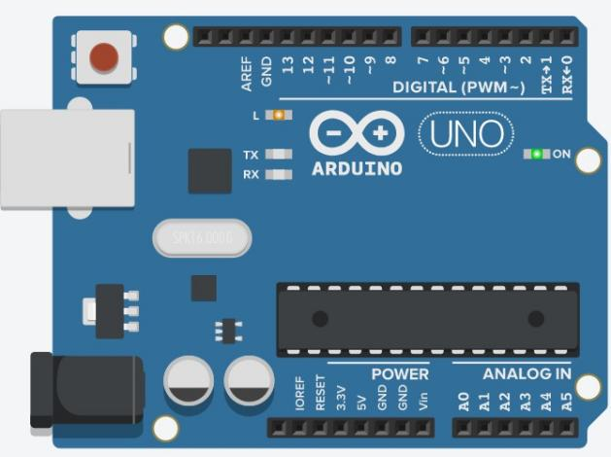

**Figure 1: Schematic of blinking of the onboard LED of the Arduino Uno**

## Code

* 1. **: write an Arduino program to blink the onboard LED without using global variable**
  2. **: write an Arduino program to blink the onboard LED using global variable**

## Observation

**Figure 2: (Simulation based blinking of the onboard LED of the Arduino Uno with a 25% duty cycle for a blink time of 2 seconds)**

**Figure 3: (Hardware Implementation based blinking of the onboard LED of the Arduino Uno with a 25% duty cycle for a blink time of 2 seconds)**

# Objective 3

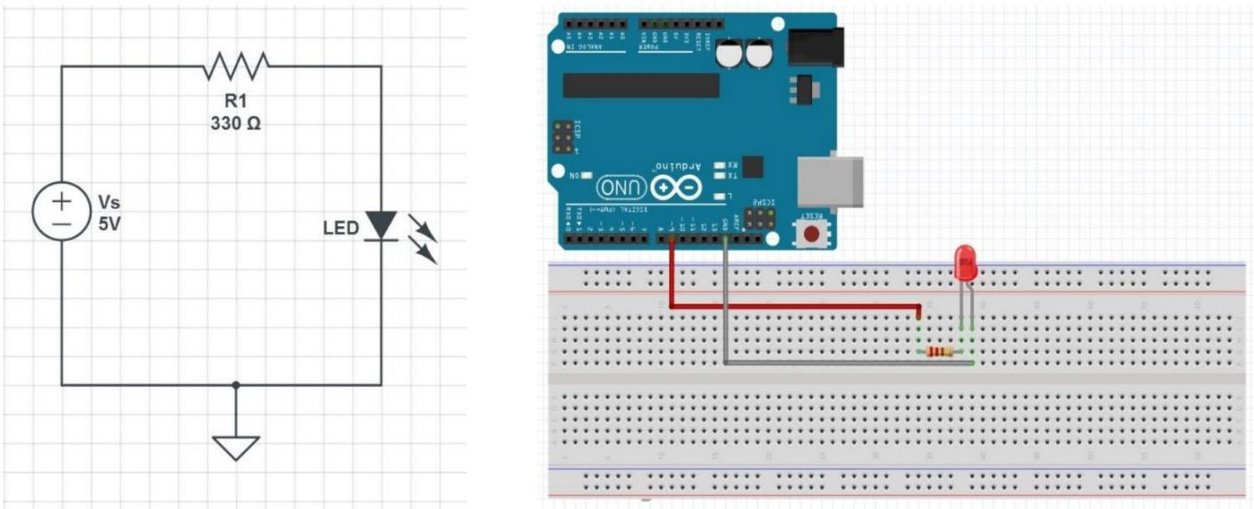**Build an external circuit using an LED and control it from the Arduino, with a 75% duty cycle and a blink time of 1 second.**

**Figure 4: Simple LED Circuit for blinking an LED Figure 5: Hardware Implementation to blink an LED**

## Code

**Observation**

**Figure 6: (Simulation based external circuit using an LED and control it from the Arduino, with a 75% duty cycle and a blink time of 1 second.)**

**Figure 7: (Hardware Implementation based external circuit using an LED and control it from the Arduino, with a 75% duty cycle and a blink time of 1 second.)**

# Objective 4

**Create a circuit with two LEDs and learn about "for loops" with the serial monitor in the Arduino sketch. The Red LED (First LED) will blink for 5 times and the Blue LED (Second LED) will blink for 3 times. The anode of the Red LED will be connected to Arduino digital pin 9, and the anode of the Blue LED will be connected to Arduino digital pin 10. The duty cycle of the Red LED will be 50%, with an on time of 200ms, and the duty cycle of the Blue LED will be 25%, with an on time of 400ms.**

## Circuit / Schematic Diagram

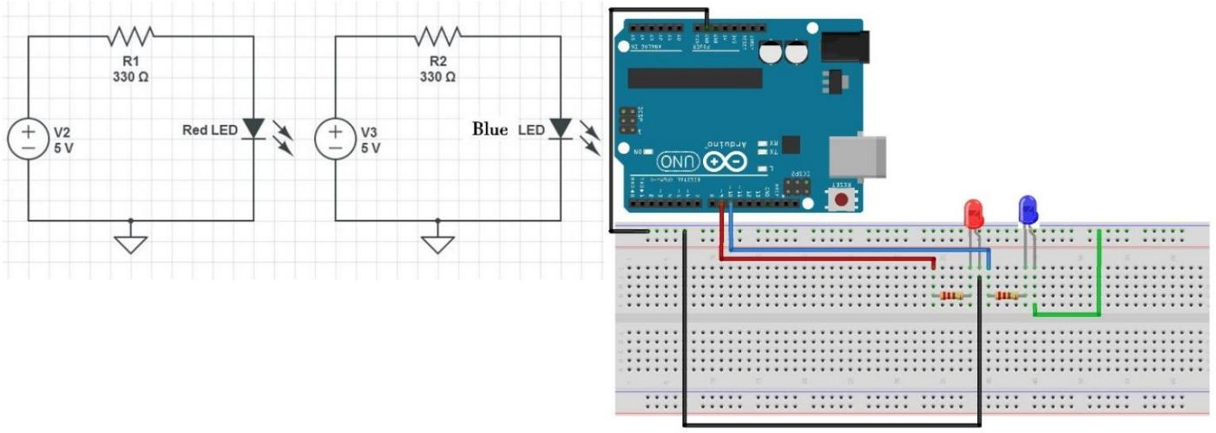

**Code**

**Figure 8: Two LED Circuit Figure 9: Schematic of two LED Circuit**

* 1. **: Control Two LED Circuit without a loop**
  2. **: Control Two LED Circuit with a for loop**
  3. **: Control Two LED Circuit with a for loop using the Serial monitor**
  4. **: Control Two LED Circuit with User Input using Arduino and Serial Monitor**

## Observation

**Figure 10: (Simulation based Two LED Circuit)**

**Figure 11: (Hardware Implementation based Two LED Circuit)**

# Objective 5

**Design and implement an LED chaser using different lighting patterns.**

## Circuit / Schematic Diagram

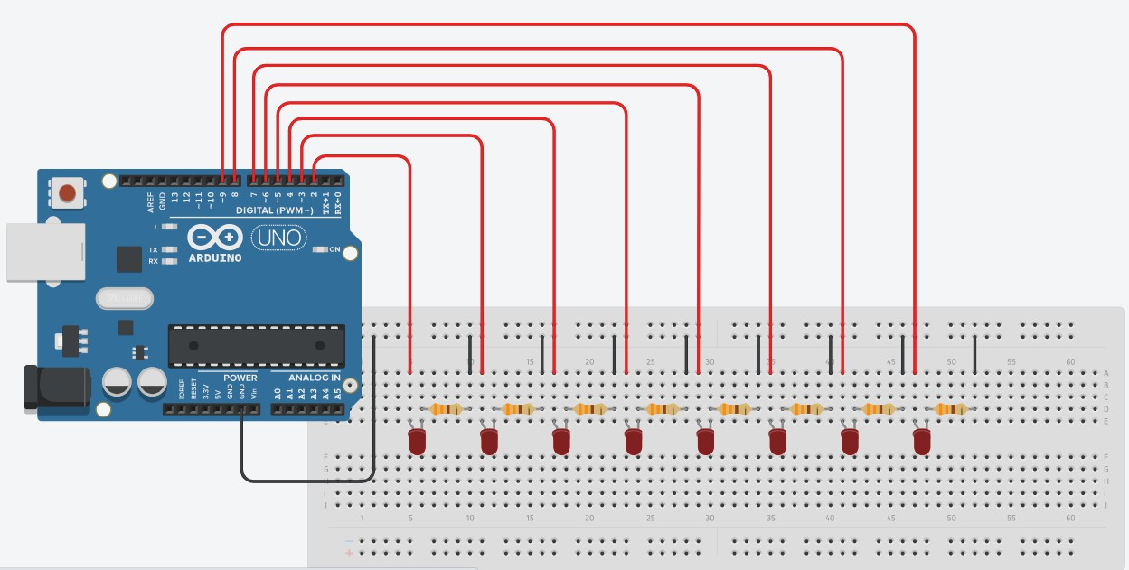

**Figure 12: Schematic of 8-bit LED chaser circuit**

## Code

**5.1 Build and Check the 8-bit LED chaser circuit: (Verify that all the LEDs light up, indicating that the circuit is connected properly)**

* 1. **Implement a basic circular LED chaser pattern.: (8 LEDs connected from pins 2 to 9)**
  2. **Implement a custom LED chaser pattern: (that combines five different patterns in a loop, including the "Bouncing Ball," "Zig-Zag," "Random Blink," "Knight Rider" and "Running Lights,")**

## Observation

**Figure 13: (Simulation based 8-bit LED chaser circuits)**

**Figure 14: (Hardware Implementation based 8-bit LED chaser circuits)**

**Conclusion:**

**Precautions:**

**Post Experiment Questionnaire:**

1. **Experiment-Specific (LED Blinking & LED Patterns)**
2. What differences did you observe between blinking an LED using a global variable versus without a global variable?
3. How did varying the duty cycle (25%, 50%, 75%) affect the LED’s brightness and blink timing?
4. Compare the LED behavior when controlled without a loop vs. with a for loop. Which method is more efficient and why?
5. When using the Serial Monitor for user input, what challenges did you face in reading and processing the input values?
6. How did the custom LED chaser patterns (e.g., Knight Rider, Random Blink) differ in implementation compared to the basic circular LED chaser?
7. **Arduino & Hardware Concepts**
8. Why is it necessary to use resistors with LEDs in Arduino circuits?
9. What role do digital pins play in controlling multiple LEDs simultaneously?
10. Explain how PWM is used in LED brightness control. Could this method be extended to motor control?
11. How does the Arduino distinguish between different LED patterns in the sketch (e.g., sequential vs. random)?
12. **Robotics & System Understanding**
13. Why are blinking LEDs often used as a first step in learning robotics and embedded systems?
14. In what ways can LED indicators assist in debugging larger robotic systems?
15. If you were to expand this experiment into a real robotic system, how might LED patterns be used for status indication or fault detection?

___________________________________________

|  |  |
| --- | --- |
| **(Signature of the Faculty)** | **(Signature of the Student)** |
|  | **Name:** |
| **Date:** | **Registration No.:** |
|  | **Branch:** |
|  | **Section** |